MOTEGUARD LOGO COLOR PLACEMENT

- Move the logo to the center upper.
- Make the logo Silver and burgundy color
- Make the logo a little bigger if you can
- Add the 3 line drop down section to the right of the upper page
- Add a search engine to the right upper side of the page and the country we are serving
- Move CONTACT US to one of the drop-down categories from the drop-down list.
- DROP DOWN LIST should have these main page categories
  - Company Overview
  - Markets
  - Capabilities
  - Insights
  - Careers
  - Investors
  - Employees
  - Suppliers
  - Contact Us
- Company Overview Subcategories
Company Overview
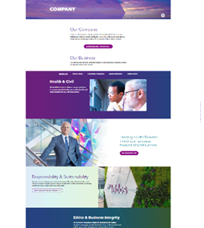
Who We Are
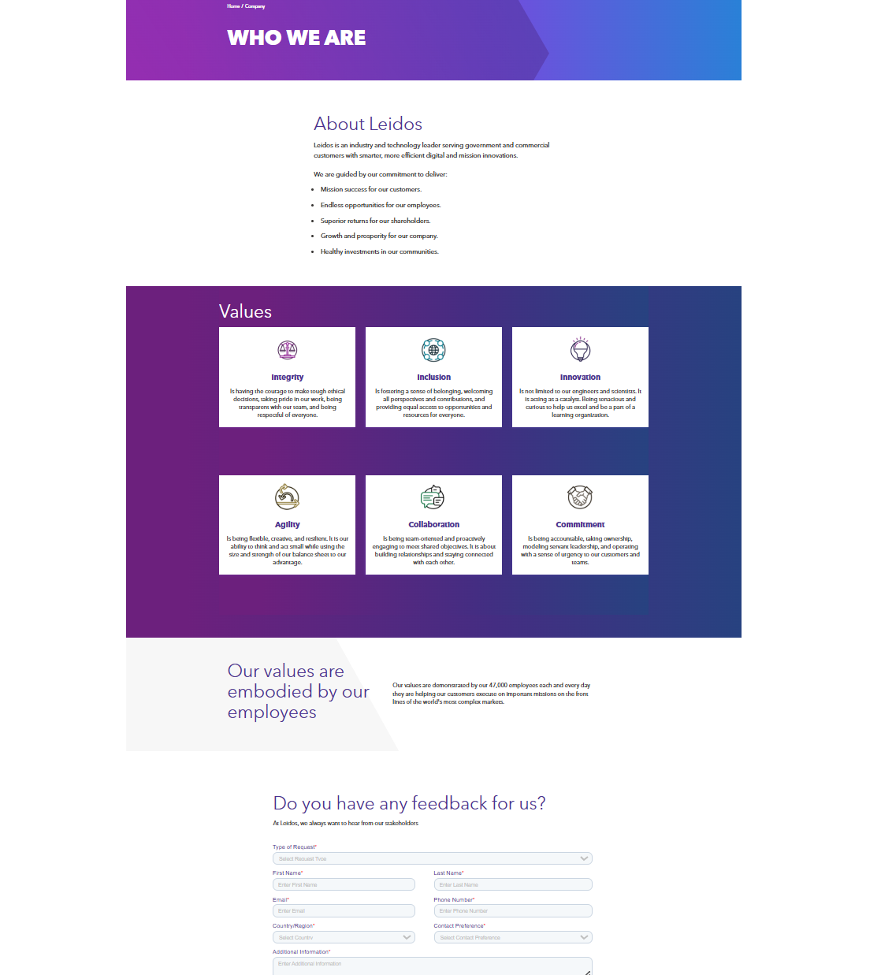
Our Business

Leadership
Responsibility & Sustainability
Ethics & Business Integrity
Partners
Contract Vehicles
Global
History

Markets Subcategories
Markets Overview
Aviation
Defense
Energy & Industry
Government
Healthcare
Homeland Security
Intelligence
Science
- Capabilities Overview
Capabilities Overview
Trusted AI Mission
Integrated Systems
Mission Operation
- Insights Overview
Insights Overview
Latest Insights
- Careers Overview
Careers Overview
Latest Opportunities
Life at Moteguard
Pay & Benefits
Frequently Asked Questions
Careers in Australia
Careers in the UK

HOME PAGE
We need this page to pop up where customers can sign up for our email marketing and solutions. It can have a Facebook connection, but we don’t have a Facebook page yet so give me your feedback.
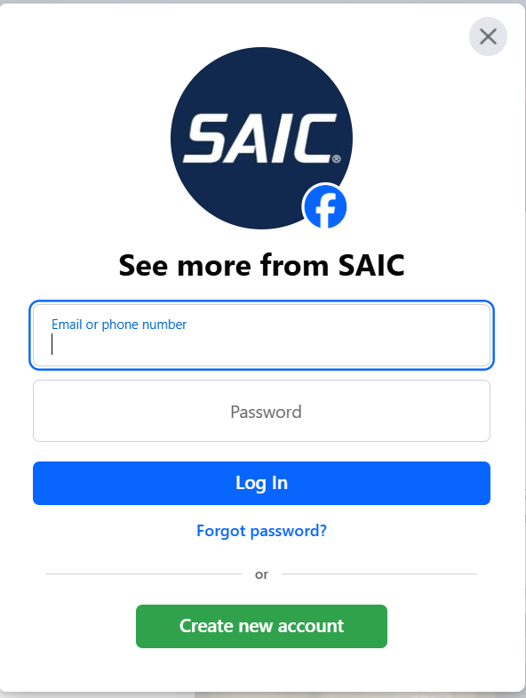

On the Home Page - We need a video playing in the background for about 2 to 4 minutes

ON THE HOME PAGE THEY WANT SOMETHING LIKE THIS
